The Hope of Glory
Revelation 10
Another Mighty Angel (Revelation 10:1-7)
- What is this “little scroll” in this angel’s hand?
- The Angel’s Voice (Hosea 11:10; Amos 3:8)
- The Seven Thunders
- Hand to Heaven (Isaiah 57:15; Genesis 14:22-23)
- The Mystery of God (1 Corinthians 2:7; Colossians 1:27)
John is commanded to take and eat the scroll. (Revelation 10:8-11; Psalm 119:103; Jeremiah 15:16; Ezekiel 3:1-4)
How should we respond to Revelation Chapter 10?
- We should accept that some mysteries are not ours to know. (Revelation 10:4; Deuteronomy 29:29; 2 Corinthians 12:4; 1 Corinthians 13:9-10)
- We should develop and work a plan to eat the book.
- We should proclaim the hope of glory in us.
  - Be Intentional
  - Be Prayerful
  - Be Respectful
  - Be Truthful
  - Be Authentic
(Lead a conversation using “Thirty Discipleship Exercises”)

Darcy, would you create business cards for this Sunday (maybe about 200) on card stock with this on the front:

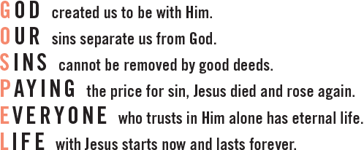

And this on the Back:
ecfellowship.com

